Archival Project: Assignment Description
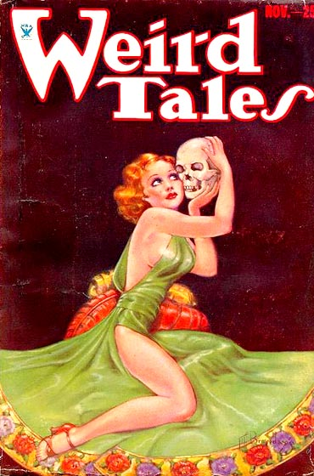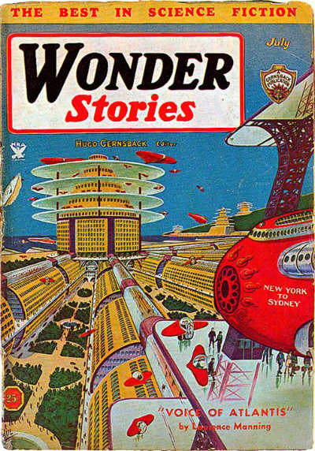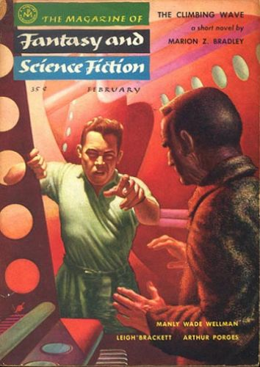
Covers of the magazines that originally published, “Shambleau,” “A Martian Odyssey,” and “The Tweener,” images from http://www.isfdb.org/cgi-bin/pl.cgi?62090 , http://www.isfdb.org/cgi-bin/pl.cgi?62235, and http://www.isfdb.org/cgi-bin/pl.cgi?61078

Pulp magazines, as we’ve discussed, were hugely important in the publication of early science fiction (and SF stories continue to be published in modern magazines). Incidentally, the Georgia Tech library archives contain a large collection of early and contemporary SF magazines.

For this project, you will:
- Visit the library archives during class time
- Find and scan (with an app) a story, its magazine cover, and any illustrations published alongside the story
- Upload your scans to Omeka, an online archive system and
- Write a paper analyzing the story’s place in the science fiction genre (using research about the genre). This paper will be an argument about how the story embodies the genre through tropes, plot elements, setting, characters, etc.

Some Restrictions
You cannot scan any stories that are in the syllabus for this course. This includes:
- Anything by Edgar Rice Burroughs (since we’ve extensively discussed John Carter)
- C.L. Moore, “Shambleau”
- Stanley Weinbaum, “A Martian Odyssey”
- Leigh Brackett, “The Tweener”
- Anything reprinted in Ray Bradbury’s The Martian Chronicles
- Philip K. Dick, “We Can Remember It For You Wholesale”

Additionally, the story that you scan must involve Mars (or another alien world) in some way and must have been published from 1930-1970.
Check with me if you’re unsure if a story meets the restrictions.

Archive Visit Days
In order to find a story, you will need to visit the GA Tech library archives, which are located next to the GA Tech library, between Crosland Tower and the Hinman Building (see this map: https://goo.gl/1GvvR6).

On the following days, we’ll meet during class time in the archives (not in our usual classroom):
- Monday, February 8
  - We’ll meet with an archival librarian to discuss the archive and will browse SF magazines
- Wednesday, February 10
  - An archival librarian will explain copyright and permissions and you’ll locate and scan a story

If you need more time in the archives, they’re open from 9 AM-5 PM Monday through Friday.
Due Date and Where to Submit
- Friday, February 12, by start of class: Draft of archival project paper due, with story and image scans
  - T-Square
    - Assignment Submission, Archival Project DRAFT
    - File formats
      - Paper: .doc or .docx only
      - Story and cover / illustration scans: .pdf and .jpg respectively
    - File Names
      - Paper: Last Name, Archival Project Draft
      - Story and image scans (use as appropriate)
        - Cover of Magazine Name, Month, Year
        - Story Title, Image #
        - Author Last Name, Story Title
  - Draft must include: Context, summary, at least 2 paragraphs of analysis, outline for remainder of paper if analysis not complete
  - We will use class time on this day for peer review, so bring a laptop with your draft file (or print it)
  - Your draft must change between this day and the final due date – the level of change depends on the project
  - Do not save over your draft when you change it
- Monday, February 15, by start of class: Final version of archival paper AND Omeka submission due
  - T-Square
    - Assignment Submission, Archival Project FINAL
    - File formats
      - Paper: .doc or .docx only
      - Story and image scans: .pdf or .jpg only
    - File Names
      - Paper: Last Name, Archival Project Final
      - Story and image scans (use as appropriate)
        - Cover
        - Image #
        - Author Last Name, Story Title
  - Omeka (http://omeka.iac.gatech.edu/OtherWorldsArchive/admin/)
    - Items: Short story (PDF), Cover image (JPG), any illustrations or advertisements that accompany the story (JPG)
    - Collection that contains all your items
    - Add your magazine cover to the “Science Fiction Magazine Covers” exhibit
  - Your Omeka submission and T-Square submission must both be on time

Required Elements for the Paper
- Content / Paper Structure
  - Provide context for the story that you found in the archives: Mention the magazine, publication date, and author (1-3 sentences)
  - Second, briefly summarize the story (at least 1 paragraph, no more than 2 paragraphs)
    - A way to frame this: “Prior to analyzing X, I want to briefly summarize the narrative for readers who may be unfamiliar with…”
  - Third, and most importantly, analyze how the story embodies the science fiction genre (at least 4 paragraphs)
    - Think about what kinds of science fiction tropes or characters are present in the story and what elements of the plot are science fictional (and why).
    - Thesis: 1 sentence in which you make a claim about how the story embodies the SF genre
    - Use quotes from and paraphrase the story to support your argument
    - Use outside sources that define science fiction (or that define subgenres of science fiction, such as planetary romance, pulp SF, feminist SF, and so on)
    - If necessary, you can compare your story to other texts / films (but your analysis is primarily an argument about the archived story, so don’t spend entire paragraphs talking about other things)
  - Finally, write a conclusion paragraph
    - Idea: Talk about modern inheritors of the SF genre that you think seem related to your short story
- At least 6 paragraphs total (12 paragraph maximum)
  - Each paragraph should be at least 5 sentences long
- Audience
  - The audience will be myself and your fellow classmates
  - Keep in mind the needs of your audience – we will not have read the story that you’re analyzing, so some summary and context will be necessary.
- Outside Sources – story + 3 (or more) sources that define science fiction or a related subgenre
  - Your outside sources should be credible and you CANNOT use Wikipedia
  - I suggest any of the following resources, which provide a lot of links to other sites, though more resources are certainly available:
    - www.sf-encyclopedia.com
    - http://sfanthology.site.wesleyan.edu/files/2010/12/FullGuide.pdf
    - http://www.depauw.edu/sfs/links.htm
  - Summarize and paraphrase sources in your own words and keep the primary focus on analyzing the story
- MLA format
  - Double spaced, 12 point, Times New Roman font
  - Upper left hand corner of first page: Your Name, My Name, Course, the Date
  - Title, centered, on first page after the above information
  - Header in the upper right-hand corner of every page: Your last name and page #
  - See https://owl.english.purdue.edu/owl/resource/747/01/ for a guideline to MLA style
- Works Cited
  - Include MLA citations for your short story and outside sources (at least 4 citations)
  - Use http://www.easybib.com/ to generate citations, but make sure they’re accurate
  - Google “MLA Owl Purdue” for guidance on MLA format and citation style
- Parenthetical Citations
  - Any time you use material that isn’t your own, do the following:
  - “Quote” or Paraphrase (Author Last Name Page #) e.g. “Citation is important” (Krafft 3).
    - If there’s no author, use a shortened title: “Citation is important” (“Archival” 3).

Informal Presentations
In class on Monday, February 15, you will speak informally to the class about the story that you scan. I will open Omeka on the main screen and you should summarize the story and its context for no more than 1 minute. We will then discuss the assignment and reflect on it as a class.

Points Breakdown
The archival project is worth 100 points total (10% of your final grade in the course). The grade breakdown is roughly as follows, and, as with all course assignments, I will use the programmatic rubric to guide my assessment of your assignment.
Points | Requirement
10 | Draft submission: Complete draft of paper submitted on Friday, 2/12 by the start of class time
5 | The Basics: Final submission on time, meets required elements
50 | Archival paper: Provides contextual information for story and makes a cogent argument about how the story embodies the science fiction genre
30 | Omeka: Scan is carefully done and metadata is thorough. Story is catalogued properly and meets the requirements of the online archival platform.
5 | Reflection: On time, meets required elements

Scanning Your Story and Images: CamScanner
You’ll need a smartphone to scan stories and images. If you don’t have one, borrow one from a friend or classmate. I’ll also bring my smartphone to our archival visits.

Download CamScanner, a free app that works for IOS and Android

To use CamScanner:
- Open the app
- Click camera icon in lower right hand corner of screen
- Use the gear-shaped icon to open settings and make sure gridlines are visible
- On the bottom of the screen
  - Select the single square for scans involving one image (e.g. cover shot, image)
  - Select the two squares for a batch scan (a scan involving multiple pages, like the story PDF)
- Click camera to scan
  - In single mode, you’ll then see a screen that allows you to crop the image – click the check mark when you’re done
  - In batch mode, you’ll stay in the scan screen, but click the photo icons on the lower left hand corner to edit / crop individual pages. Click the check mark after editing and scanning all pages.
- After you click the check mark, you’ll get to the document screen – click the open triangle in the upper right hand area to share
  - Share story scans as PDF, images / covers as JPG file
  - Send the scans to your email OR cloud drive account (they’ll stay in the app, but this is how you can get the files to a computer)

Ensure that any scans you make are legible.
Scan in a well-lit area and avoid, if possible, casting shadows on your scans or scanning hands / fingers.
If the app adds kind of text on the bottom of your scans, use a simple image editor to crop this out.

This site lists some alternative phone scanner options: http://lifehacker.com/five-best-mobile-document-scanning-apps-1691417781.

Using Omeka
To access and add materials our Omeka site, go to http://omeka.iac.gatech.edu/OtherWorldsArchive/admin/
Note that this URL is case-sensitive
Log in with your GA Tech credentials

To Add An Item:
- In the left hand navigation bar, go to “Items” and then click “Add an Item”
- On the screen entitled “Dublin Core,” enter the following information:
  - Title (use what’s appropriate for what you’re adding)
    - “Title of short story”
    - Cover of Magazine Name, month and year
    - Illustration from “short story”
  - Description: 3-5 sentence summary of what happens in the story
  - Creator (use what’s appropriate for what you’re adding)
    - Author of story
    - Illustrator name (if you can find it)
  - Contributor: Your first and last name
    - Important for making sure I know who adds what to the archive
  - Source: Bud Foote Science Fiction Archives, GA Tech
  - Publisher: Name of magazine that published story
  - Date: Date of story or image’s publication (Month or Season, Year)
- After entering the Dublin Core metadata, go to “Item Type Metadata”
  - Select “text” for short story, “still image” for cover or illustration
- Go to “files” and click “browse” to upload your file
- Go to tags and add at least 5 individual words, separated by commas, that describe the story’s content, location, or subject matter. Then click “add tags”
- After you’ve done all this, click “Add Item” on the right hand side of the screen
  - Do NOT check the box marked “public,” unless you have acquired permissions for this item
    - This is IMPORTANT: Keeping the box unchecked is crucial for keeping the archive visible only to a GA Tech audience (as the archives belong to GA Tech)

After adding your items, make a collection:
- In the left hand navigation bar, go to “Collections” and click “Add a Collection”
- On the screen entitled “Dublin Core,” enter the following information:
  - Title: “Title of Short Story”
  - Description: Cover image, text, and illustrations for “Title of Short Story” by Author First Name Author Last Name
  - Creator: Author of story
  - Contributor: Your first and last name
    - Important for making sure I know who adds what to the archive
  - Source: Bud Foote Science Fiction Archives, GA Tech
  - Publisher: Name of magazine that published story
  - Date: Date of story or image’s publication (Month or Season, Year)
- After you’ve done all this, click “Add Item” on the right hand side of the screen
  - Do NOT check the box marked “public,” unless you have acquired permissions for the items

After you add your collection:
- In the left hand navigation bar, go to “items”
- To quickly find your items, click “search items” and use the “search by user” dropdown menu
- Under your item, click “edit”
- In the right hand side of the screen, under “collection,” select the name of the collection that you just created
- Click “save changes”
- Repeat this for every item you make – your story, cover image, and illustrations will all be in one collection
  - Do not add things to, edit, or change collections created by other users

Add your cover image to the exhibit:
- In the left hand navigation bar, go to “exhibits”
- Under “Science Fiction Magazine Covers,” click “edit”
- Where it says “pages,” click “add page”
- Title your page “Cover of Magazine Title, Month, Year”
- Page slug name should be: MagazineTitleMonthYear
- Under “content,” select “file with text” and click “add new content block”
- Under “items,” click “add item” and add your magazine cover image
- In the text field, write:
  - 1-2 sentences explaining or describing the cover image and then the following information (starting on same line):
  - In this issue of Magazine Name, you can find “Short Story Title” by Author First and Last Name. [hit enter, start new line]
  - Student First and Last Name scanned this item on Month, Day, Year.

During class on Friday, February 12, I’ll go through how to add things to Omeka.
I can also provide instruction with Omeka during archive days or during my office hours the week the draft is due, if you need additional assistance.

Programmatic Rubric
Scale | Basic | Beginning | Developing | Competent | Mature | Exemplary
Rhetorical Awareness  Response to situation, including purpose, audience, register, and context | Overlooks two or more aspects of the situation or assignment, and thus does not fulfill the task | Overlooks at least one aspect of the situation or assignment and thus compromises effectiveness | Attempts to respond to all aspects of the situation or assignment, but the attempt is incomplete | Addresses the situation or assignment in a complete but perfunctory or predictable way | Addresses the situation completely, with unexpected insight | Addresses the situation in a sophisticated manner that could advance professional discourse on the topic
Stance  Argument, significance and implications (“so what” factor) | Involves an unspecified or confusing argument; significance is not evident | Makes an overly general argument; significance is difficult to discern, or not appropriate to the rhetorical situation | Makes a simplistic or implicit argument, or multiple arguments that have no clear connection to one another; gestures towards significance, but does not fully develop it | Makes an explicit and straightforward argument that does not oversimplify the problem or question; explores at least one implication of the argument in depth | Makes a complex, unified argument that clearly articulates a position or stance; explores multiple implications of the argument | Offers an inventive, expert-like argument that clearly articulates a sophisticated position/stance; explores multiple implications of the argument in a compelling manner
Development of Ideas  Evidence, analysis, and substance | Claims requiring support are not backed by necessary evidence; lacks analysis of major pieces of evidence; content is not substantive | Evidence and/or analysis is weak or contradictory; does not account for important evidence that could support or disprove the argument | Evidence provides minimal but necessary support to each point; attempted analysis is not sufficient to prove the argument | Evidence and analysis are substantive; they support the argument and related claims, but are mostly predictable | Evidence fully supports and proves the argument and all related claims; evidence is always paired with compelling analysis | Evidence and analysis are precise, nuanced, fully developed, and work together to enhance the argument,
Organization  Structure and coherence, including elements such as introductions and conclusions as well as logical connections between points | Lacks unity in constituent parts; fails to create coherence among constituent parts; contains major argumentative holes or fallacies | Uses insufficient unifying statements; uses few effective connections; some logical moves necessary to prove the argument are absent | Uses some effective unifying claims, but a few are unclear; inconsistently makes connections between points and the argument; employs simplistic organization | States unifying claims with supporting points that relate clearly to the overall argument and employs an effective but mechanical scheme | Asserts and sustains a claim that develops logically and progressively; adapts typical organizational schemes for the context; achieves substantive coherence | Artifact is organized to achieve maximum coherence and momentum; connections are sophisticated and complex when required
Conventions  Expectations for grammar, mechanics, style, citation | Involves errors that risk making the overall message distorted or incomprehensible | Involves a major pattern of errors | Involves some distracting errors | Meets expectations, with minor errors | Meets expectations  in a virtually flawless manner | Exceeds expectations and manipulates conventions to advance the argument
Design for Medium  Features that use affordances of the genre to enhance factors such as usability and comprehensibility | Lacks features necessary or significant for the genre; uses features that conflict with or ignore the argument | Omits some important features; distracting inconsistencies in features; uses features that don’t support argument | Uses features that support the argument, but some match imprecisely with content; involves minor omissions or inconsistencies | Supports the argument with features that are generally suited to genre and content | Promotes engagement and supports the argument with features that efficiently use affordances | Persuades with careful, seamless integration of features and content and with innovative use of affordances

Peer Review and Changing Your Draft
We will spend part of class on 2/12 doing peer review of your drafts. This means that you will receive feedback from a classmate on your work, which will allow you to make changes to your work between draft and final submission.

If you miss class on this date, you will not receive the benefits of peer review. However, I will still expect you to make changes between the draft and final versions of your project – these changes will just be based on your own self-reflection.

Reflection
On Monday, 2/15 during class time, I will ask you to reflect on the project. You’ll then save that reflection and return to it later in the semester as you prepare your final portfolio.

This reflection is not optional and will count toward your grade for this project, so if you miss class when the assignment is due, you should still plan to submit the reflection on Monday, 2/15 by the end of the day.

The reflection should be submitted on the class blog (http://blogs.iac.gatech.edu/mars1102).
Title: Last Name, Archival Reflection
Categories: In Class Work AND Reflection
3 tags

Answer each of the following questions with 2-3 bullet points PER QUESTION and 1-3 complete sentences PER BULLET POINT.

- What were the main intellectual goals of the archival project assignment? Please situate these goals in terms of the course theme and in terms of the communication skills you were to learn or practice.
- What is your argument or purpose in the archival project paper? How did you make the argument or purpose visible and persuasive in your artifact?
- Who is the intended audience for your artifact; why is this an appropriate audience? How is your choice of audience reflected in your artifact?
- What are the defining features of the genre or media that you are using in this project (i.e. rhetorical essay AND the Omeka digital archive)? How do you make use of these features?
- If you had more time for revision, what would you change and why?

Lateness Policy
I will not accept the draft late – if you do not submit the draft by Friday, 2/12 at the start of class time, you will not receive credit for the draft element of this assignment.

The reason for this is that we will spend 2/12 on peer review activities, so coming to class empty-handed will mean that you would not be able to participate in that day’s class. If for some reason you have to miss class that day, you will still be able to submit the draft via T-Square.

I will reduce the grade for your final version of archival project by 10% for each day that it is late (including weekends).

Revision and Extension Policy
In this class, you may choose to revise 1 blog post or the archival project.
See the syllabus for my revision policy.

If you want to use your 1 assignment extension for this project, follow these steps:
- Contact me at least 24 hours before the assignment is due through an email in which you explain the reason for the delay (OR have a documented excuse from the institute).
- Propose in this email a reasonable extension (72 hours at most past the due date), which you MUST then keep. Past this new date, your assignment will receive the normal lateness penalty.

